NATIONAL UNIVERSITY OF MODERN LANGUAGE ISLAMABAD
Lab 05


Submitted to:
Ms. Fatima Gillani
Submitted by:
Zulqarnain Hassan
Roll No: …………………… SP21379
Subject: …………………… SCD
Department: ……………… BSSE-5-Afternoon
Date: ……………………… 25-10-2024

Task 01
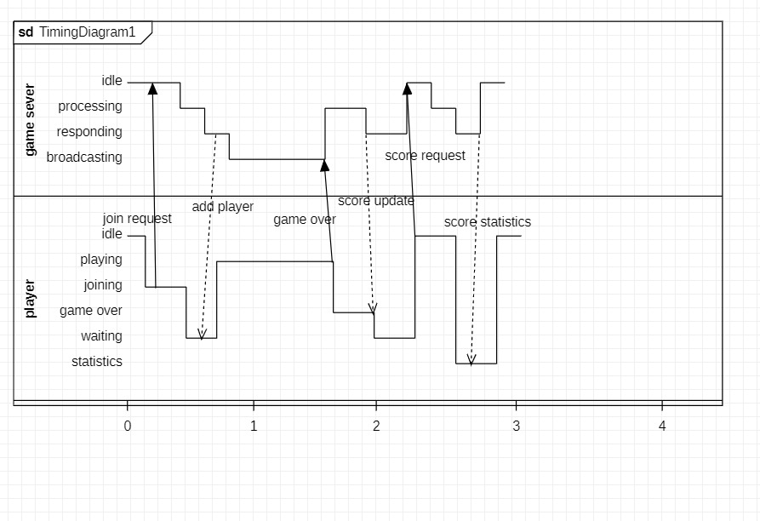
Task 02
